Message: Revolutionize Your EV Charging Experience with chrgd

**White Labelling**

**Showcase your brand to the world.**

**With our bespoke solution, you have the ability to customize the interface and branding, creating a seamless and consistent experience that aligns with your business identity.**

**Analytics**

**Unlock the power of data-driven decision-making.**

With over 15 types of data sets available, we provide you with in-depth analytics to help you plan for the future, optimize charging efficiency, and enhance customer satisfaction.

**API Integration**

**Seamlessly integrate our system with other platforms or vice versa.**

By building an API integration layer, we enable smooth data exchange and collaboration between different systems, ensuring a streamlined charging experience for your customers.

**Booking**

**Plan ahead and manage your charging needs efficiently.**

Our advanced booking system empowers users to reserve slots in advance, while operators can easily manage and optimize the reservations, ensuring a seamless charging experience.

**My Vehicle**

**Gain valuable insights about your EV.**

Choose your vehicle from our extensive list of EV models and access additional data specific to your car. Filter charging stations based on your vehicle specifications, ensuring compatibility and a personalized experience.

Reference: <https://www.catec.ae/software>

Discover chrgd's Robust Feature Suite

**iOS and Android Compatible (icon)**

**Issue management system** **(icon)**

**Charger Status. (Icon)**

**Creating Community (icon)**

**Load management system (icon)**

**Smart Parking Integration (icon)**

**Multi-language & Multi-currency Support (icon)**

**Remote Software Updates (icon)**

**Advanced Filtering (icon)**

**Remote Start and Stop (icon)**

Reference: <https://www.ampeco.com/>

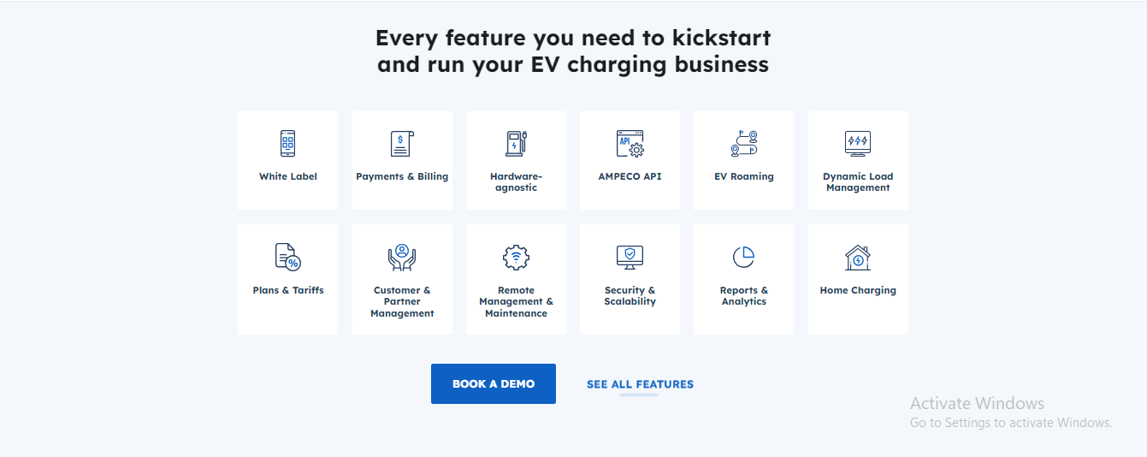

**Who is chrgd for?**

|  |  |  |  |  |  |  |
| --- | --- | --- | --- | --- | --- | --- |
| **Charge Point Operators** | **Homes** | **Car Dealerships** | **Hotels** | **Corporates** | **Governments** | **Charger Manufactures** |

**Reference:** [**https://monta.com/uk/business-solutions/residential-charging/#dropdown**](https://monta.com/uk/business-solutions/residential-charging/#dropdown)

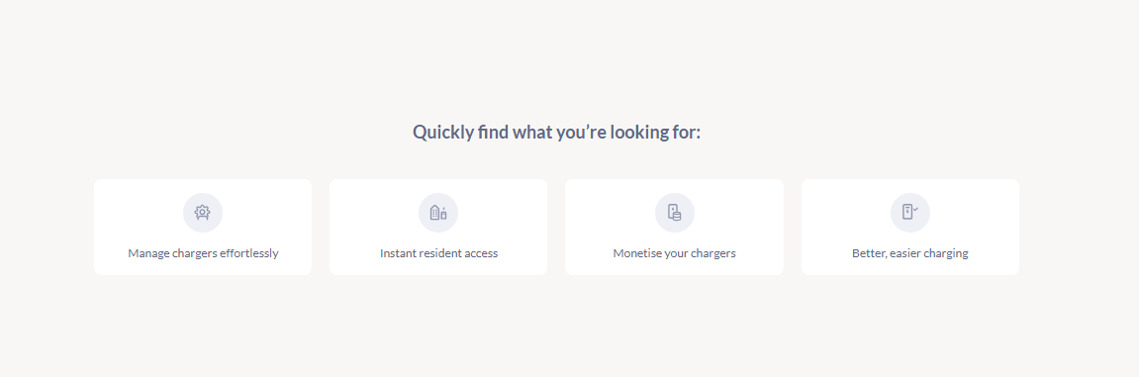

**Ready to experience what it’s like always being chrgd?**

|  |
| --- |
| **Get Started** |

**Reference:** [**https://monta.com/uk/features/**](https://monta.com/uk/features/)

